  Free Career Starter resources
  view online

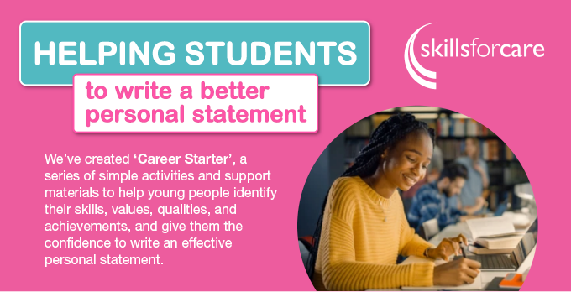
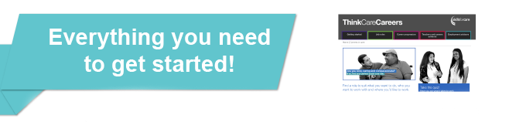

‘Career Starter’ is contextualised in social care but is a valuable tool for ALL students, no matter what pathway they choose. All resources are available free to download at: www.skillsforcare.org.uk/thinkcarecareers

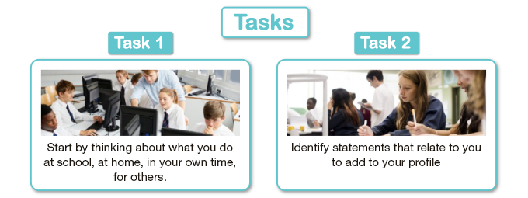
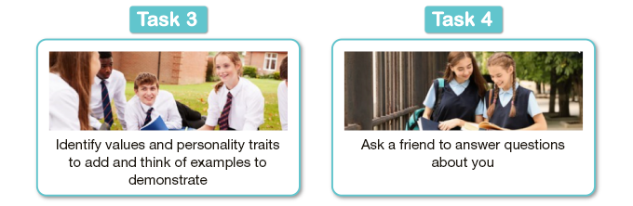
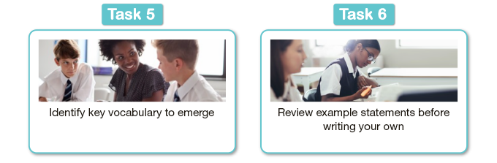
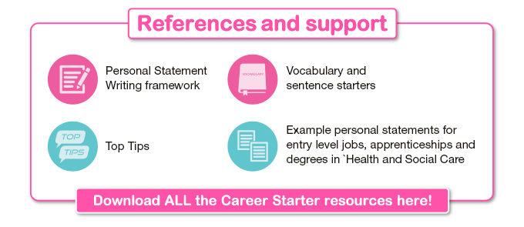


The Career Starter activity is just one way we support young people, and teachers of Careers Education and Health and Social Care.
Our Think Care Careers website contains workplace videos, pathway animations, case studies, job descriptions, a myth-busting presentation and more, to help you bring sessions on Careers and lessons in Health and Social Care to life.

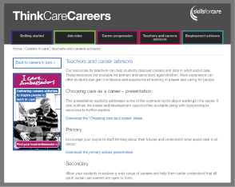




Plus a presentation to help you
introduce pupils to careers in Social Care.
The secondary schools Careers Slides explore a wide range of careers and the development opportunities offered by a career in social care



To find out more visit: www.skillsforcare.org/thinkcarecareers
Skills for Care Ltd, West Gate, Grace Street, Leeds, LS1 2RP.
Registered company no. 3866683. Registered in England charity no. 1079836.
Group VAT no. 135 538313.
© Skills for Care 2022. All rights reserved.

