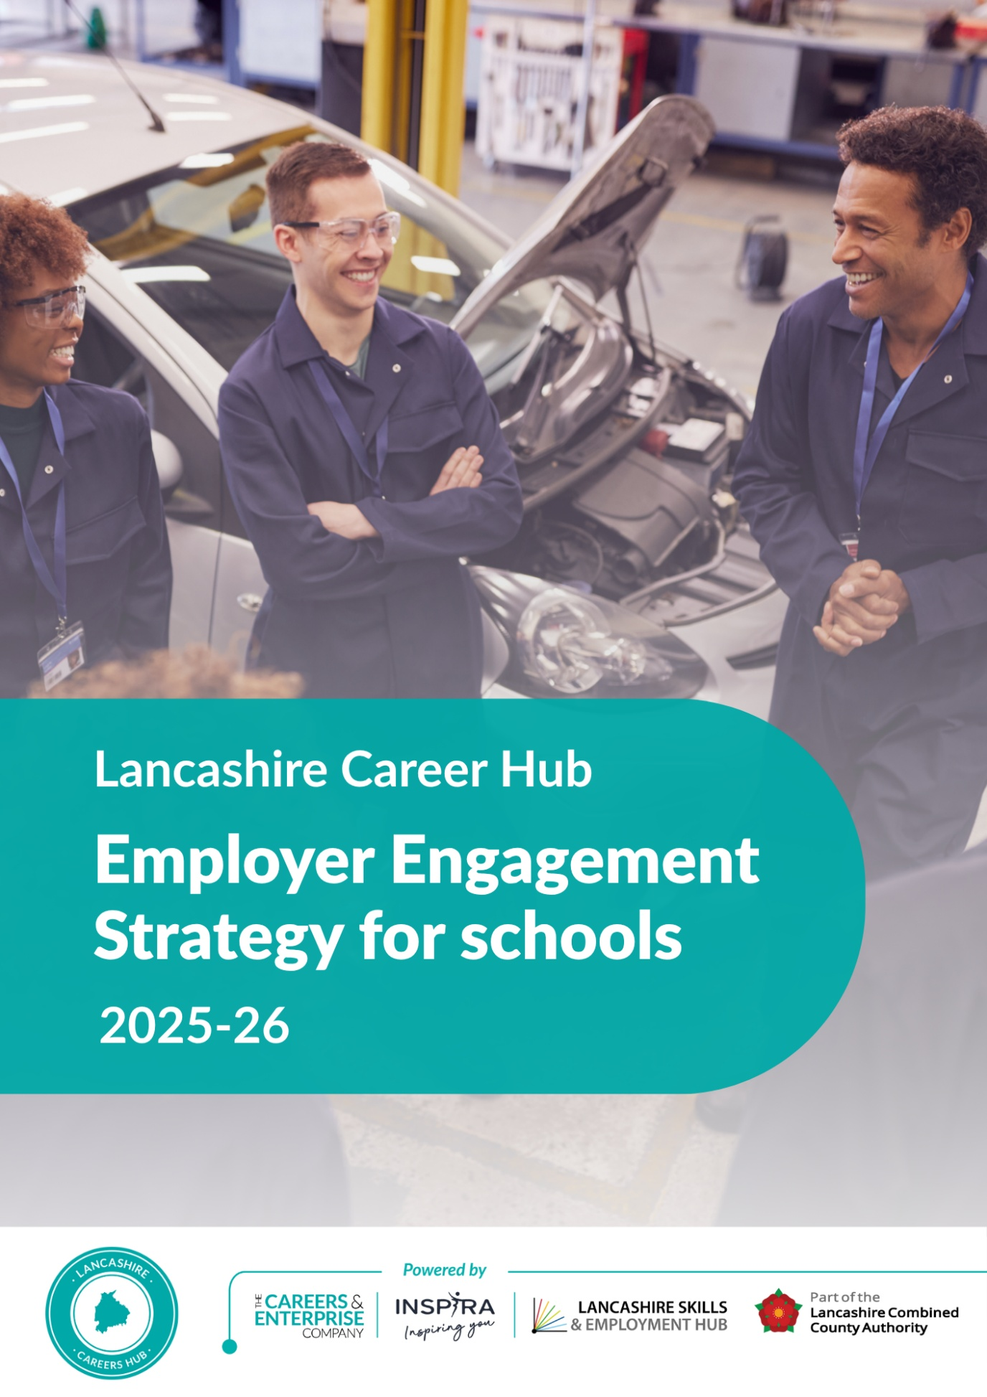

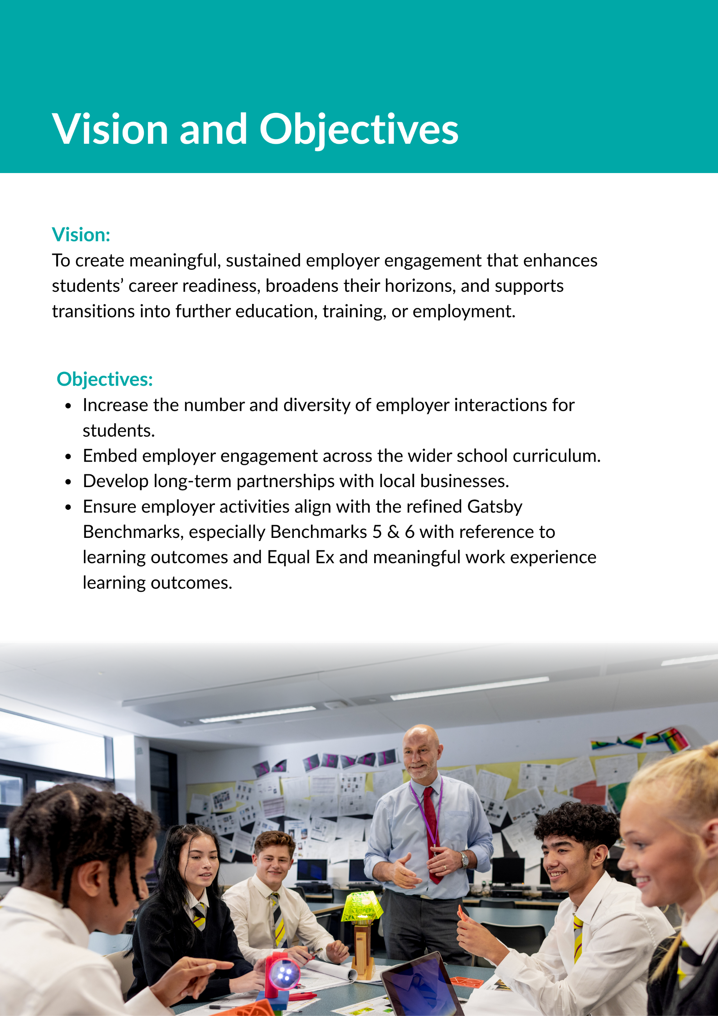


Strategic Pillars

Mapping & Targeting Employers
- Audit existing contacts: Identify current employer relationships (as a school, staff, parent and carer and alumni community) and gaps.
- Segment employers: By sector, size, proximity, and relevance to curriculum.
- Target outreach: Focus on sectors aligned with local labour market needs and student interests.

Building Relationships
- Create a value proposition: Show employers how engagement benefits them (CSR, talent pipeline, staff development).
- Appoint employer champions: Staff or governors who advocate and broker relationships.
- Use alumni networks: Engage former students now in employment to inspire current learners.

Designing Meaningful Encounters
- Workplace visits and or safaris
- Employer talks and panels
- Curriculum-linked projects and visits
- Mock interviews and CV workshops
- Progressive modern work experience opportunities
- Virtual 2-way engagement options for remote or time-constrained employers
- Inclusivity & Accessibility: Activities should be tailored to meet the diverse needs of students, including those with SEND and from disadvantaged backgrounds, ensuring equitable access to employer engagement.
- Safeguarding: All employer engagements must comply with school safeguarding policies. Where relevant, employers may be required to provide DBS checks or work under supervision.

Embedding in Curriculum
- Collaborate with subject teachers to integrate employer input into lessons.
- Use real-world problems and case studies provided by businesses.
- Encourage departments to adopt an “employer-linked” unit each year.
- Promote and embed Work Ready Lancashire, Lancashire Local Labour Market Information tools such as the Portal.

Communication & Coordination
- Develop a central calendar of employer events.
- Use Compass + to track contacts, interactions, and feedback.
- Share success stories via newsletters, social media, and school website.

Monitoring & Evaluation
- Collect feedback from students and employers after each activity.
- Track impact on student aspirations, destinations, and skills development using FSQ.
- Use Compass+ (Careers Partners), Internal Leadership Reviews and FSQ to evaluate progress and measure impact against the refined Gatsby Benchmarks.

Employer Engagement Pack.
1. School Overview
- School Name & Location

- Type of School (e.g. secondary, sixth form, academy)
- Mission & Values
- Careers Programme Summary
- Refined Gatsby Benchmark alignment

- Key priorities for employer engagement
- Ofsted Rating & Highlights (if relevant)

2. Student Demographics
- Total Number of Students

- Year Groups Covered
- Gender Breakdown
- Pupil Characteristics e.g. SEND, Pupil Premium
- SEND & Pupil Premium Statistics
- Ethnic Diversity
- Post-16 Destinations Data
- Local Labour Market Context (brief summary)

3. Engagement Menu for Employers
A clear, flexible menu of ways businesses can get involved:
Activity | Description | Time Commitment
Careers Talks | Share your career journey, industry insights, and advice | 30–60 mins
Curriculum Projects | Co-design or support subject-based challenges | 1–3 hours
Workplace Visits | Host small groups of students for tours and Q&A | Half or full day
Work Experience | Offer placements for Year 10/12 students | 1 week
Mentoring | Support students with career planning and confidence | Monthly
Mock Interviews | Help students practice interview techniques | 1–2 hours
CV Workshops | Review and advise on student CVs and applications | 1–2 hours
Apprenticeship Info Sessions | Promote pathways and opportunities | Flexible
Speed Networking | Short, timed conversations with multiple employers | 1–2 hours
Enterprise Days | Support student-led business or product challenges | Half or full day
Dragons’ Den Panels | Judge student pitches and offer feedback | 1–2 hours
Job Role Spotlights | Introduce niche or emerging roles in your sector | 30 mins
Virtual Q&A Panels | Join online sessions with students across schools | 1 hour
Industry Insight Videos | Record short videos about your role or sector | Flexible
Teacher CPD Sessions | Help staff understand your industry better | 1 hour
Parent Engagement Events | Speak at careers evenings or fairs | 1–2 hours
Career Fairs | Host a stall and speak with students and parents | Half day
Real-World Problem Solving | Present a challenge for students to solve | 1–3 hours
Sponsorship or Prizes | Support events or competitions with resources | Flexible
Advisory Role | Join the Lancashire Careers Hub network of Enterprise Advisers | Termly

4. Contact Details

- Careers Leader Name:
- Email Address:
- Phone Number:
- School Address:
- Social Media / Website:

5. Why Partner with Us?

- Access to future talent
- Fulfil CSR and community goals
- Staff development through volunteering
- Raise awareness of your industry/sector
- Build long-term relationships with education

Appendix:
Employer Encounter Planning Checklist for Cross Curricular Employer Engagement
✔ | Planning Step
☐ | Identify a real employer/employee from a relevant or varied sector (including SMEs, self-employed, public/private)
☐ | Define the purpose and learning outcomes (e.g. to learn about a job role, industry, pathway, or skills)
☐ | Ensure the session is interactive – includes Q&A, task, discussion, or live demo
☐ | Provide a preparation activity (e.g. students research the job or write down questions)
☐ | Agree the format and logistics: live talk, panel, demo, virtual, in-class, etc.
☐ | Confirm session is age and level appropriate
☐ | Assign a staff lead or facilitator to manage time and support
☐ | Include a reflection activity post-session (written, verbal, creative, digital)
☐ | Collect feedback from students and employer
☐ | Record and track the encounter for Gatsby/Compass+ documentation

