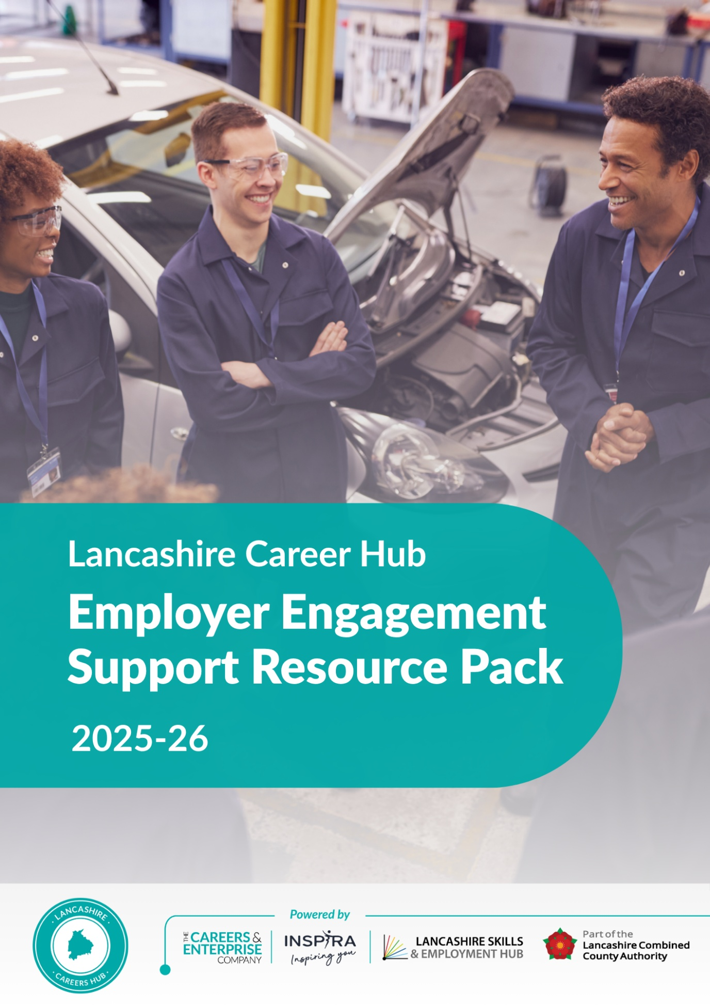

Employer Engagement Pack.

This guide is designed to help employers understand the many ways they can support schools and colleges in delivering high-quality careers education that meets the needs of all learners.
Whether you're a large organisation, a local business, or a self-employed professional, your insights and experiences can make a lasting impact. By partnering with schools, you help students explore career pathways, develop essential skills, and build confidence in their future choices.
This guide outlines practical examples of employer involvement aligned to the Gatsby Benchmarks 5 and 6, with tailored approaches for:
- Mainstream Secondary Schools
- SEND Settings
- Alternative Provision
- Further Education Colleges

When engaging with a school you should expect to receive information on the following to help you plan any activities:

1. School Overview
- School Name & Location

- Type of School (e.g. secondary, sixth form, academy)
- Mission & Values
- Careers Programme Summary
- Refined Gatsby Benchmark alignment

- Key priorities for employer engagement
- Ofsted Rating & Highlights (if relevant)

2. Student Demographics
- Total Number of Students

- Year Groups Covered
- Gender Breakdown
- Pupil Characteristics e.g. SEND, Pupil Premium
- Cultural & Ethnic Representation
- Inclusivity and Accessibility requirements
- Post-16 Destinations Data
- Local Labour Market Context

3. Engagement Menu for Employers
A clear, flexible menu of ways businesses can get involved:

Activity | Description | Time Commitment
Careers Talks | Share your career journey, industry insights, and in an assembly, lesson or part of an event. | 20–60 mins
Curriculum Projects | Co-design or support subject-based challenges | 1–3 hours
Workplace Visits | Host small groups of students for tours and Q&A | Half or full day
Work Experience | Offer placements for Year 10/12 students | Flexible
Mentoring | Support students with career planning and confidence | Flexible
Mock Interviews | Help students practice interview techniques | 1–2 hours
CV Workshops | Review and advise on student CVs and applications | 1–2 hours
Apprenticeship Info Sessions | Promote pathways and opportunities | Flexible
Speed Networking | Short, timed conversations with multiple employers | 1–2 hours
Enterprise Days | Support student-led business or product challenges | Half or full day
Dragons’ Den Panels | Judge student pitches and offer feedback | 1–2 hours
Job Role Spotlights | Introduce niche or emerging roles in your sector | 30 mins
Virtual Q&A Panels | Join online sessions with students across schools | 1 hour
Industry Insight Videos | Record short videos about your role or sector | Flexible
Teacher CPD Sessions | Help staff understand your industry better | 1 hour
Parent Engagement Events | Speak at careers evenings or fairs | 1–2 hours
Career Fairs | Host a stall and speak with students and parents | Half day
Real-World Problem Solving | Present a challenge for students to solve | 1–3 hours
Sponsorship or Prizes | Support events or competitions with resources | Flexible
Advisory Role | Join the Lancashire Careers Hub network of Enterprise Advisers | Termly

4. Contact Details

- Careers Leader Name:
- Email Address:
- Phone Number:
- School Address:
- Social Media / Website:

5. Why Partner with Us?

- Access to future talent
- Fulfil CSR and community goals
- Staff development through volunteering
- Raise awareness of your industry/sector
- Build long-term relationships with education

Benchmark 5 Examples
Every learner should have multiple opportunities to learn from employers about work, employment and the skills that are valued in the workplace.
A meaningful encounter will:
• Have a clear purpose, which is shared with the employer and the young person
• Be underpinned by learning outcomes that are appropriate to the needs of the young person
• Have opportunities for two-way interactions between the young person and the employer
• Be followed by time for the young person to reflect on the insights, knowledge or skills gained through the encounter

Mainstream Secondary School
Example: Employer Q&A Panel – “World of Work Week”
- Year 10 students attend an interactive event with a panel of local employers from diverse sectors and education pathways, including digital, healthcare, trades, and creative industries.
- Employers give brief (5-minute) introductions about their roles, their route to that role, what work is like, the skills required and what it takes to be successful. This is followed by a Q&A session with pre-submitted and live student questions.
- Teachers support the event by preparing students with learning outcomes, discussion prompts, the preparation of questions prior to the event and by facilitating engagement on the day.
- Following the event, students reflect about what they’ve learned about pathways, routes into those industries, and how to gain employment in the sector that interested them most.

SEND School
Example: Employer “Job Talk” with Interactive Task: Supermarket Staff visit the school.
- Teachers support the event by preparing students with learning outcomes and discussion prompts, and by supporting students on the day.
- A small group of students meets two staff members from a local supermarket (one manager, one customer assistant).
- Staff explain their jobs using visual aids and bring props (uniforms, packaging, tills) for students to explore.
- Students try a simulated “checkout challenge” with support, followed by Q&A.
- Staff use simplified language and Makaton-friendly materials.
- Following the visit, students complete a reflection task to think about what jobs they learned about, which job they liked the most and whether they might like to do that job one day.

Alternative Provision (AP) School
Example: Talk and Demonstration by a self-employed tradesperson (e.g. Barber or Builder)
- A local self-employed barber visits the school and delivers a short talk on how they trained, what their day involves, and the business side of self-employment.
- They bring tools and demonstrate a skill (e.g. hair-clipping technique or fade blending).
- Students ask questions about training, money, and challenges.
- Teachers support the event by preparing students in advance with learning outcomes, question preparation in advance and question prompts. They facilitate engagement on the day.
- Staff help students complete a “Job Snapshot” worksheet after to reflect on what they learnt about the roles, the skills needed and how to follow their footsteps in the future.

FE College
Example: Employer Talk Series in Curriculum – “Career Insights Week”
    - Over a week, course-specific employers (e.g. for Business, Health & Social Care, Digital, Construction) visit classes.
    - Each guest talks about their career journey, current job, and recruitment needs in that sector.
    - Students interact through guided questions prepared with tutors.
    - Employers highlight different routes into their fields (apprenticeships, degrees, freelancing, etc.).
    - College staff support the event by preparing students in advance with learning outcomes, question preparation in advance and facilitating engagement during the session.
    - Following the event, students reflect about what they’ve learned about pathways, routes and employment opportunities in the sector.

Benchmark 6 – Experiences of Workplaces
“Every pupil should have first-hand experiences of workplaces to help their exploration of career opportunities and expand their networks. This could be achieved through visits to workplaces, work shadowing and/or work experience.”

A meaningful experience will:
• Have a clear purpose, which is shared with the employer and young person
• Be underpinned by learning outcomes that are appropriate to the needs of the young person
• Involve extensive two-way interactions between the young person and employees
• Include opportunities for young people to meet a range of different people from the workplace
• Include opportunities for young people to perform a task set by the employer or to produce a piece of work relevant to that workplace
• Include the employer providing feedback to the young person about their work
• Be followed by opportunities for the young person to reflect on the insights, knowledge or skills gained through their experience

Benchmark 6 Examples
Mainstream Secondary School
Example: Year 10 5-day Work Experience Placement at a Local Retail Chain
Before: Learning outcomes are shared. Students are prepared for the experience by attending CV workshops, employer preparation sessions in school. Employers may choose to interview students prior to the placement.
During: Students experience a range of on-site tasks include shadowing different departments (stock, tills, customer service) and given the opportunity to talk to lots of different staff.
Interaction: Interaction in the form of daily check-ins with a named workplace mentor to reflect on performance, skills and knowledge learnt.
After: Students complete a reflection workbook aligned to skills/employer expectations.

SEND School
Example: Preparing for Supported Internship Day at a council parks and gardens department.
Before: Students have a guided session using visual timetables to prepare for the environment and tasks. Teachers share learning outcomes with students.
During: Students engage in a range of work related experiences e.g. planting, watering, light maintenance, all supervised by a trained inclusive staff members.
After: Teaching staff support students to discuss what they enjoyed, found challenging, what new things they learnt and future steps.

Alternative Provision (AP) Setting
Example: Work Shadowing Placement with a local car garage.
Before: School staff supports student in exploring what to expect (sensory, social, emotional factors) along with learning goals.
During: Student shadows a self-employed mechanic doing real jobs. This consists of light interaction, observation, some supervised tasks (e.g. tool cleaning, part-fetching).
After: Student records reflections in a voice note or drawing format (adapted to learning style).

FE College
Example: T-Level Industry Placement (315+ hours) with a digital marketing firm.
Before: Placement brief, induction, safeguarding session.
During: Student works on real campaigns, attends team meetings, and uses industry software. Student interacts with a range of staff.
After: Supervisor provides feedback; student updates digital portfolio and discusses skills learned with tutor.
All activities should be fully evaluated once completed.

